deviantArt in spotlight: Analyzing Immense Image Repositories
Almila Akdag Salah, Albert Ali Salah, Bart Buter, Nick Dijkshoorn, Davide Modolo, Quang Nguyen, Sander van Noort, Bart van de Poel

Abstract
deviantArt is one of the most important online communities in the context of user-generated artworks. Unlike Flickr, which hosts all kinds of photographs, deviantArt is devoted to artistic creations, and covers a wide range of styles ranging from traditional arts to digital arts, photography, film and manga. The community portal has now a collection of more than 100 million images, organized around a hierarchical category structure that labels each image into one of about 2.000 categories. With its 13 million members and 32 million yearly visitors, surpassing any real or virtual museum, deviantArt offers a genuine virtual space for disseminating art. It generates a platform free of institutional and governmental politics, democratizing the way arts are generated, shared and enjoyed. As such, it is a very interesting venue for art historians, new media scholars and digital humanities research in general. The main goal of this paper is to understand this collaborative and autonomous venue and to analyze the dynamics of its underlying social network. A secondary goal is to introduce an exploratory paradigm, as well as the theoretical and practical tools necessary to investigate arts collections with immense volumes.
Numerous studies on social networking sites have produced ways of characterizing relevant aspects of these networks, their connection structure and growth patterns. Following these studies, we characterize deviantArt as a graph structure with each artist being a node, and social links as arcs. What makes deviantArt special in terms of its network structure is that it has galleries of artworks associated with each of its nodes. Using computer vision techniques, it is possible to automatically compare the images that make up those galleries with each other. This kind of comparison helps us find patterns and regularities, trends and similarities automatically. Traditional methods of analysis break down in the face of millions of artworks.
So far, a scholarly study of deviantArt has been missing. We direct our efforts in isolating the aspects that are most relevant in characterizing the social structure of deviantArt, which is by no means a trivial task. The deviantArt website offers various web-based services to its members enabling and enforcing a strong social interaction, which lies at the heart of the site’s evaluation system. Each member’s homepage lists some basic statistics such as page visits and the number of comments, downloads and the number of times the member’s artwork is saved as a favourite. At the first look, these numbers seem to be the most important measures of the success in deviantArt. However, a network analysis reveals a different picture.
Not all the active and value-creating members of the site are artists producing acclaimed works. Basic membership to deviantArt is free of charge and does not depend on any social conditions; to become a member one does not need to have any prior investment or education in arts. Thus, there is a vast difference in the quality of the uploaded images, depending on the background and involvement of the members. Some members rarely upload their own images, and instead act as connector points between actively creating members through their social interaction in deviantArt space. Some members publish news or articles, or have regular journal entries featuring other deviants. Some are professional artists interested only in uploading images and disregarding the social conventions of the site. It is also possible to sell one’s artworks through the web portal, and most of the members who make money through this service take on deviantArt’s offer for extra services in exchange for a small amount of monthly payment.
To get to the core of the deviantArt network, we have used a number of assumptions that would weed out most of the members, and help us reach a manageable and relevant set of users. The first heuristic is the subscription status; the paying members of the site are more serious users and have access to more services. These can be automatically determined through scraping. Our first data reduction followed these members, and we thus obtained a network with 100.000 nodes and about 4,5 million links, each representing a user being watched by another user. Watchers get notifications about the activities of the members they are watching. Thus, if a member has a high number of watchers, he/she is able to reach out to a bigger audience whenever he/she uploads an artwork.
To get to the core of this sub-network, we have recursively removed nodes (and all connecting edges) that had only a few watchers. Each iteration of this procedure peels off one shell from the peripheries of the network, leaving us finally with a densely-connected graph [Fig. 1]. We have then analyzed this core network in itself and in relation to the larger network. The representatives of the core network give us a fair picture of the relative structure of categories, and how they are positioned with respect to each other. We have also developed an OpenSource visualization tool that acts as a magnifier for a selected subset of nodes, to visualize and compare many galleries at once [Fig. 2]. The toolkit has built-in selection of over twenty visual features, and allows more abstract visualization of artworks through its different views [Fig. 3]. Taken together, these tools combine network analysis, computer vision and information visualization for the investigation of deviantArt.

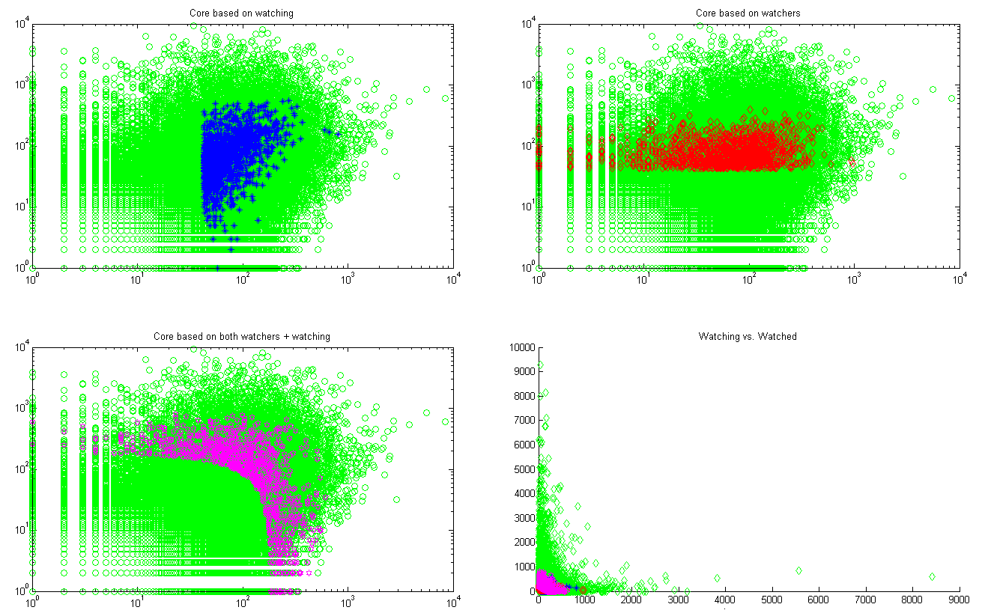
Figure 1: Visualization of the deviantArt core network. The green dots represent the whole network of paying users. The core network can be created by setting a threshold on the number of watching users (top left), the number of watched users (top right) or both (bottom left). The bottom right figure shows the power-law behavior of the degree distribution.

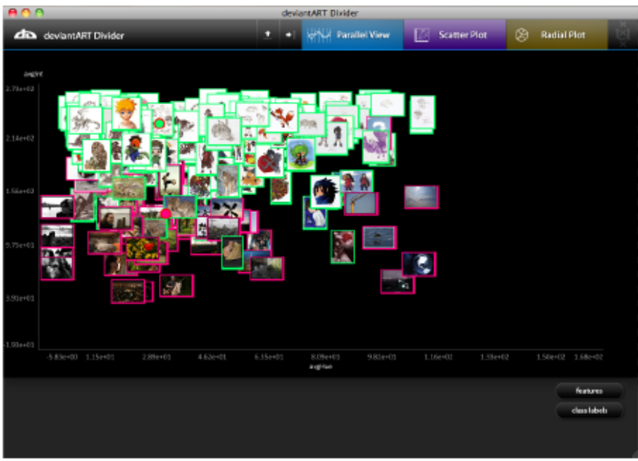
Figure 2: The visualization application displaying a scatter plot of two artists, using average intensity and average hue as projection dimensions.

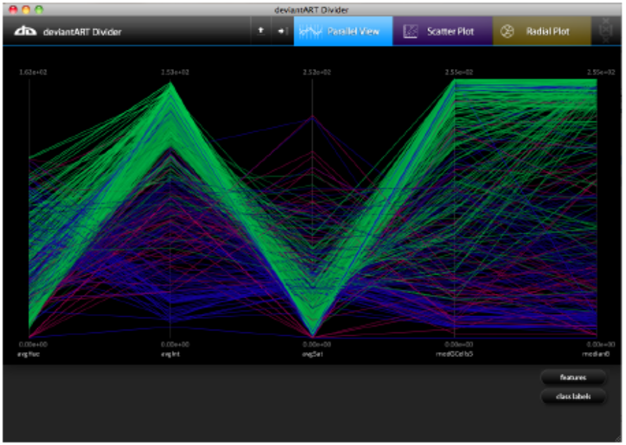
Figure 3 The visualization application displaying a parallel coordinates plot of three artists over five features. Each line depicts one artwork, and colors are used to denote individual artists.

